# **Assigment:**

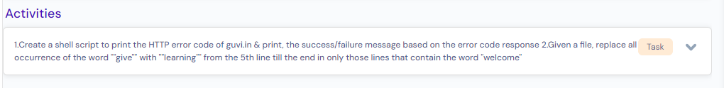

# Case-1 (create a shell script to print the HTTP error code of guvi.in) :

HTTP 2XX is success code

3XX is redirection.

4XX is client error.

5XX is server error.

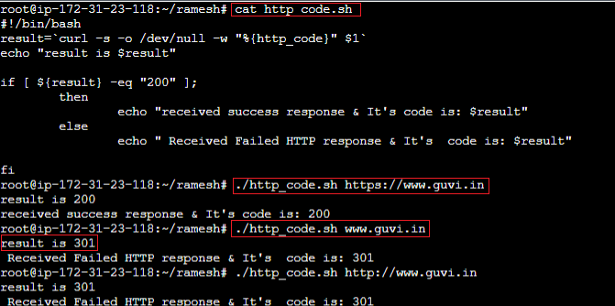

# Case-2 (Given a file, replace all occurrence of the word ""give"" with ""learning"" from the 5th line till the end in only those lines that contain the word "welcome"

**Shell Script:**

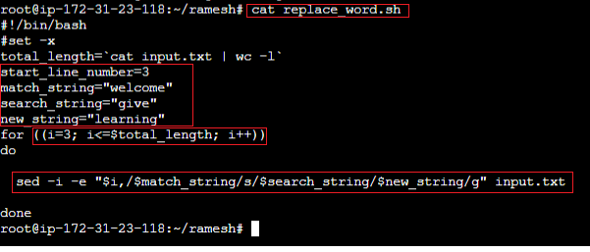

**Note:**

1. **I took an example to start search and replace if specific word matches from 3rd line onwards. If we want to start checking from 5th line, we can set “start_line_number = 5”**
2. **set mach_string=” welcome”**
3. **set search_string = “give”**
4. **set new_string=” learning”**

**input.txt file content before change:**

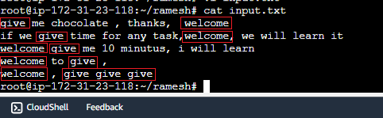

**Input.txt file content after change:**

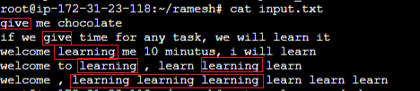

# sed command usages:

## Practice-1: command: search and replace an old string with new string.

**sed -i “s/old_string/new_string/g” input.txt**

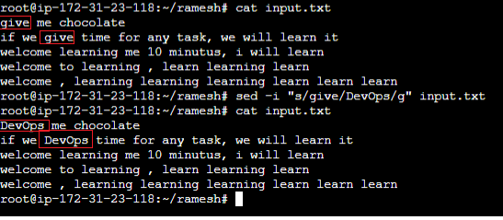

## Practice-2: command: search and replace an old string with new string.

**sed -i “s/old_string/new_string/” input.txt.**

since, we did not give “/g” (global), this command only replaces first occurrence in each line with new string even though we have multiple occurrence in same line.

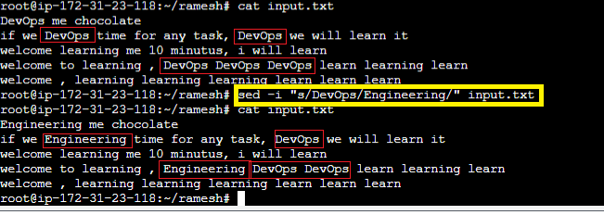

## **Practice-3:** search and replace with new string if matches with particular string.

sed -i -e "/match/s/old_string/new_string/g" file

